一：文客首页

100%



0.5%

4.7%%

2.8%

18.4%

0.4%

48.1%

18.4%

0.9%

47.2%

6.1%

0.9%

10.4%

31.5%

31.5%

21.3%

1.1%

1.9%

21%



3.0%

4.3%

1.1%

2.1%

3.0%

13.1%

13.5%

13.1%

12.2%

4.2%

二：文客行动



4.0%

4.9%

5.7%

5.9%

8.8%

11.6%

8.3%

29.7%

60.0%

6.8%

47.2%

三：校园首页

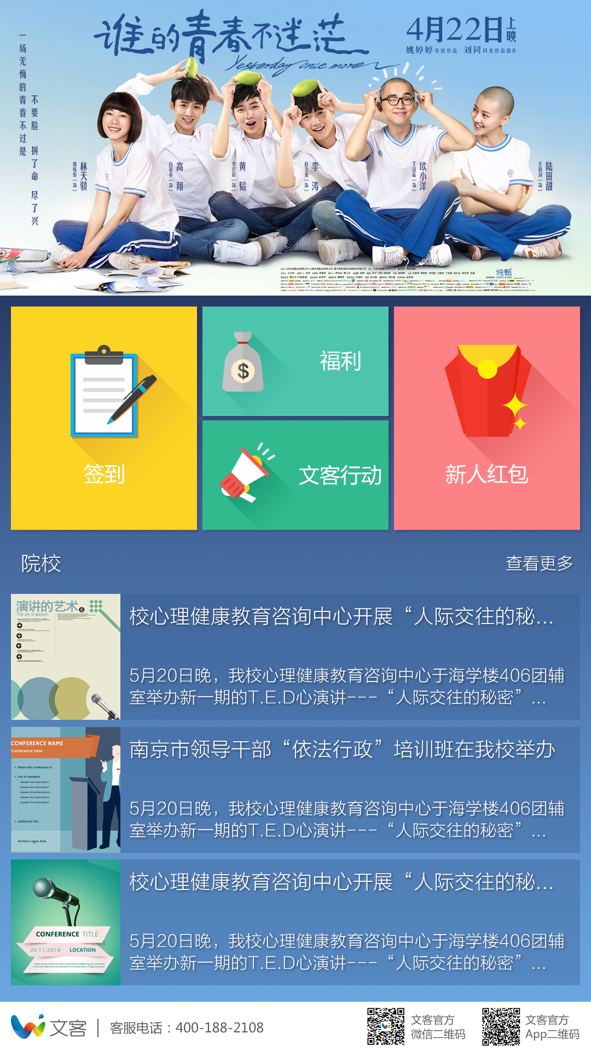

fc8286

4dc5ac

4dc5ac

颜色fcd424

1.6%

1.9%

1.6%

0.7%

4.0%

18.5%

6.1%

96.3%

12.0%

四：文客列表



2.2%

8.8%

1.1%

1.4%

3.0%

11.6%

23.8%

17.7%

7.5%

五：院校列表

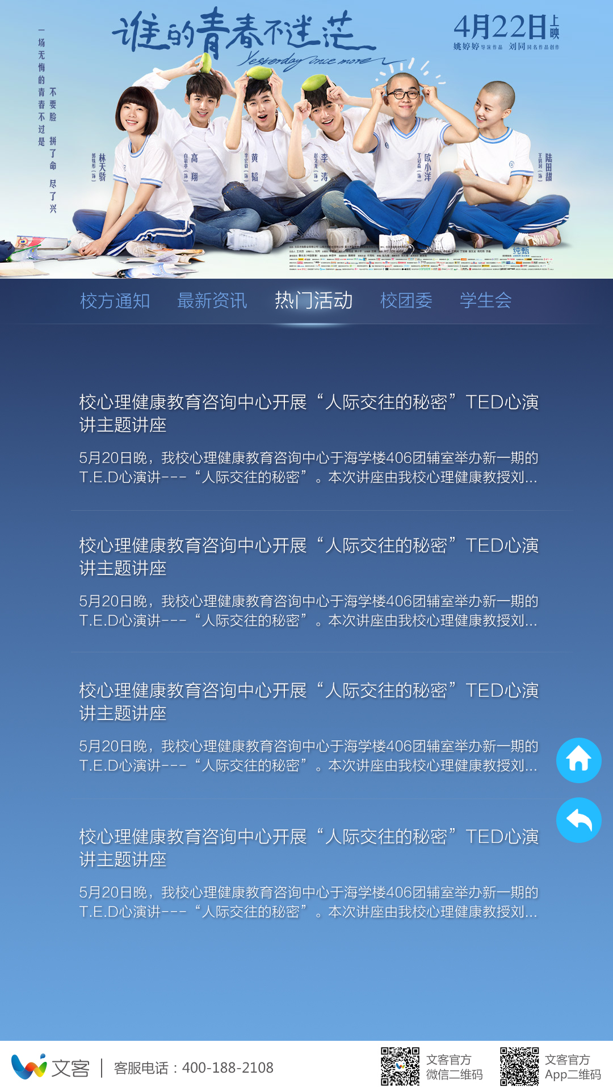

2.6%

11.3%

4.8%

11.9%

6.4%

75.4%

12.8%

六：详情

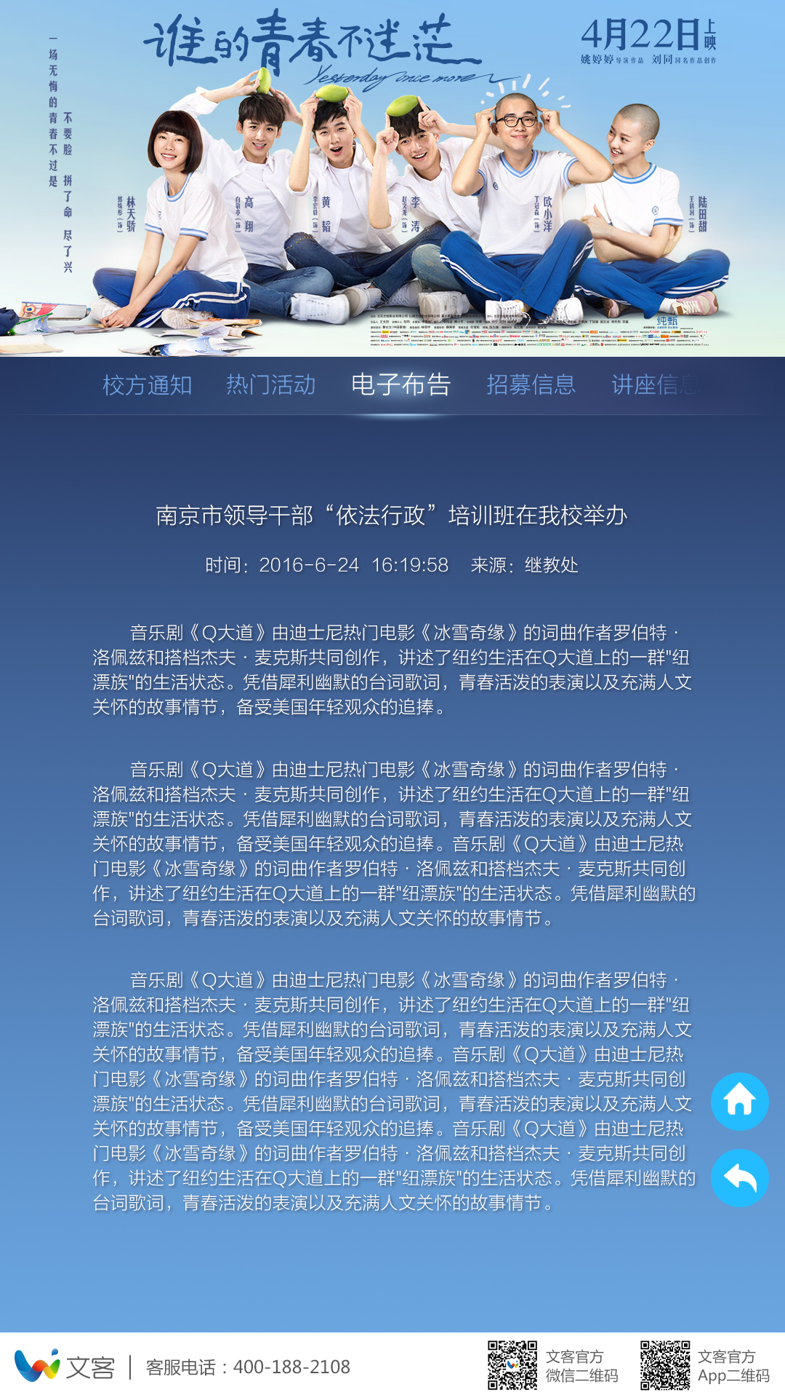

9.0%

3.2%

3.7%

2.3%

11.6%%

七：文客详情

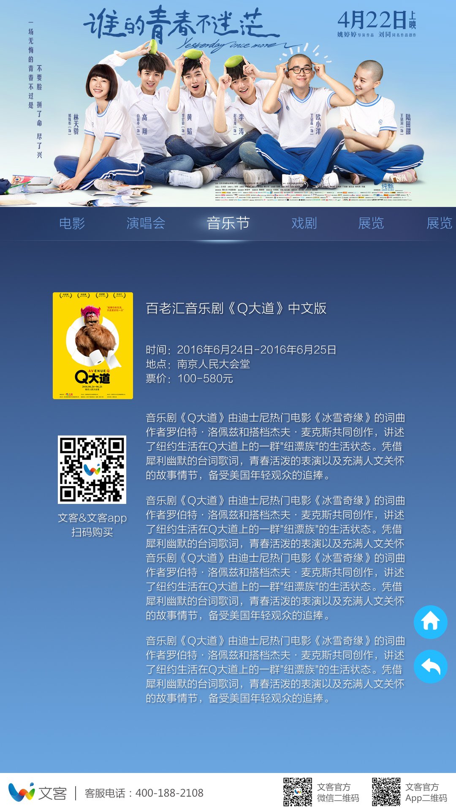

1.1%

60.7%

8.7%

8.4%

17.7%

3.7%

3.9%

1.3%

6.3%

13.2%

11.6%